Tracking the movement of the Soccer Transfer Window

Paul Tekleab

GEOG498G: Topical Investigations; Models and Methods for Spatial Data Science

Taylor M. Oshan, Ph.D.

December 16, 2020

**Introduction that outlines the goals/ problem statement**

My proposal is centered on the soccer transfer window. This system consists of the selling club, the buying club, players, and agents constantly in negotiations to discuss transactions (Matchett 2013). This window consists of players moving to different teams in different countries for common reasons such as an increase in salary, an increase in the chance of winning trophies, and to live in a warmer climate (Matchett 2013). Teams purchase players to market and advertise them to bring more awareness to the team, increase the chance of winning trophies, have sold out stadiums, and attract diverse fans (Matchett 2013).

My proposal will analyze the movement of soccer players from one team to another as well as the amount of money being spent between teams in Europe from the period of July 27, 2020, when the window opens until October 5, 2020, when the window closes. Exploring data in this period has been interesting particularly with the current state of affairs with the COVID-19 pandemic. The small clubs were at a disadvantage in being able to improve their roster since they had to reshuffle funds towards coping with the pandemic and they don’t generate as much revenue from sponsors and merchandise sales because of the financial disparity in the sport (Delaney 2020).

The big teams in England like Manchester United, Arsenal, and Liverpool were impacted as well, but since they have massive contracts with TV networks, they were able to purchase a few players (Delaney 2020). Nonetheless, Chelsea, a team in England had a transfer ban where they couldn’t spend any money in 2019, so in this window, they had a competitive advantage in using the money they saved up in going after players other teams simply couldn’t afford to (Delaney 2020). The goal of my project is to develop web maps in python and an animation that demonstrates money and player movement taking place between teams in 2020.

**Literature review that summarizes previous work on the same tasks for use of the same**

**data or analytical methods**

One literature review that introduced me to develop thoughts on my topic was “A method to identify defensive assignments in team-based invasion sports using spatiotemporal trajectories” (Leichsenring et al. 2020). Reading through this journal article parts that stood out was the use of GIScience in identifying general motion patterns in team-based sports, using spatiotemporal data to analyze basketball player's movement, and studying basketball player's behavioral patterns (Leichsenring et al. 2020). I have always retained a heavy interest in sports and this article discussing the amount of movement that occurs in sports lead me to hone in on the movement in soccer in relation of the market world.

The literature that had me brainstorming with the idea of mapping leaflet and folium markers on my map was the article “Accidental, open and everywhere: Emerging data sources for the understanding of cities” (Arribas-Bel 2014). For instance, in figure 3 the map displays the Metropolitan Transportation Authority of New York City, I saw how the dots were connecting with each stop the train would travel to (Arribas-Bel 2014).

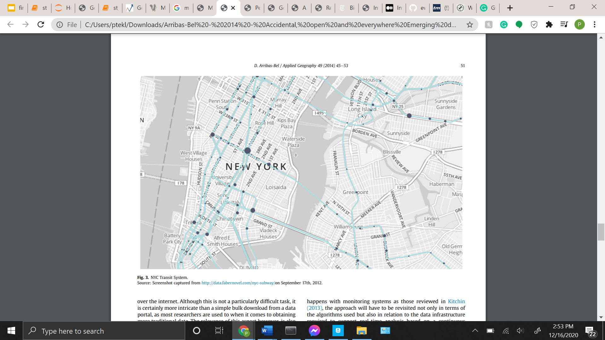

Fig. 3 (Arribas-Bel 2014)

Applying leaflet gave a similar representation but instead of a Metropolitan Transit System, I connected the dots of transfer activity amongst teams. Likewise, in figure 1 the map displays different color circle markers of the top five popular places and top five unique things to do in New York City (Arribas-Bel 2014). Seeing this display led me to research how I could apply these symbols to my data. In the end, I was successful in creating markers traveling from one country to another.

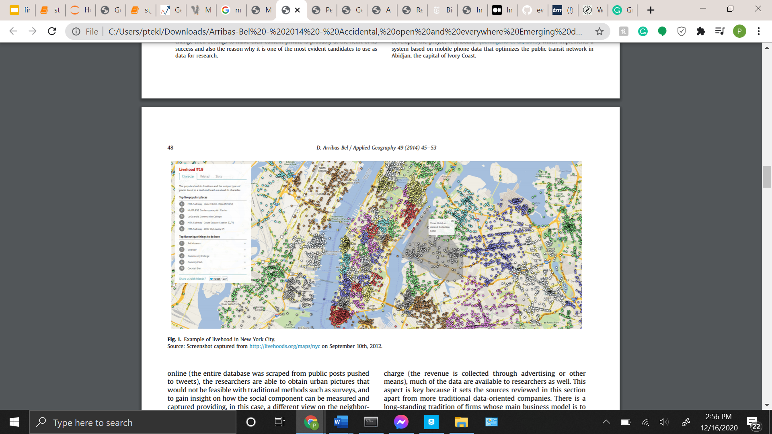

Fig. 1 (Arribas-Bel 2014).

Furthermore, the literature review that summarized some hurdles I came across with the difficulty in web mapping the data was “Research Challenges in Geovisualization” (MacEachren Kraak 2013). The first error the article highlighted was developing a theory for geo representation and formalizing representation methods (MacEachren Kraak 2013). I understood this issue because I incorporated leaflet in visualizing my data, and I was quite dissatisfied with the display. Of course, I was able to solve this problem by switching gears from leaflet to folium. The second error the article emphasized was adapting representation methods to meet the changing nature of data (MacEachren Kraak 2013). I could relate to this issue since when folium began working, I was having trouble with getting folium to comply with each of the 9 CSV data sets. To resolve the error, I had to create custom folium markers for each CSV file to correctly display the transfer activity occurring between teams across Europe.

The article “The of Big Data” highlighted how big data is unstructured data using advanced techniques of artificial intelligence and pattern recognition makes the data more understandable to computers (Lohr 2012). The data I obtained was unstructured data due to some of the information was missing in terms of the geometry and the fee amounts that certain players costed. The article discussed artificial intelligence technologies like using Google searches to navigate the California roads (Lohr 2012). In my project, I added a search bar in the top right corner of my final map for the user to navigate through the soccer transfer data.

The article “Inference and analysis across spatial supports in the big data era: Uncertain point observations and geographic contexts” emphasized the impacts of big data with geographic inquiry in terms of mobility and movement (Robertson Feick 2018). Moreover, it discussed big data detailing the times and locations of electronic purchases, and movements (Robertson Feick 2018). In my project, I had to do a similar procedure in detailing the buying club, the selling club, the player's name, age, position, and the fee for which the player was sold for.

**Choice of data and describes the nature of the data and potential limitations**

The source of the data that I selected was from https://www.transfermarkt.co.uk/ and a GitHub repository from https://github.com/ewenme/transfers. The transfermarkt provides the latest scores in the sport, the most rising and valuable players, transfers, rumors, market values, and a list of all the soccer teams in Europe (2). This source details each transfer that occurred between teams and players. Likewise, along with the purchases this source shows the players statistics like how many goals, assists, clean sheets, yellow and red cards they have for a season and in their career. After each game, the site is programmed to update the market value of players based on the performance. The source also has a forum where the soccer community can comment and give their opinion on a player in terms of their market value and what team they would best fit based on their strengths and weaknesses.

From the GitHub repository, I read in 9 CSV files that had the data that involved team name, player name, age, position, and price tag (1). The 9 files had soccer league information pertaining to the English Premier League, UK Championship, German Bundesliga, Spanish La Liga, Dutch Eredivisie, French Ligue 1, Italian Serie A, Portuguese Liga, Russian Premier Liga. One potential limitation I noticed after observing the data was it had a geometry column but didn’t show geographical coordinates (1). To fix this issue I manually inputted geocoding by researching the latitude and longitude coordinates for where the teams in each of the 9 leagues. Another limitation was not all of the transfer fees were recorded in some of the CSV files, so to resolve the limitation I would often refer back to transfermarkt to enter the correct figures (2).

**Outline of methods employed**

I employed several frameworks and methods for my project. They were leaflet, folium, ant path, glob, and matplotlib animation. Leaflet instilled interactive widgets like zoom level, hand mouse, and themes highlighting countries on my maps for greater interactivity (Quanstack 2019). The leaflet didn’t work initially, but it helped shape the geographical visualization method I wanted to display in the end. It didn’t work in not interactively showing any type of movement taking place, it just connected the dots of the geographical coordinates that I found, it was a trial and error stage. It worked in helping me understand what to research to envision player and money movement. After further research and exploring the class repository, I used folium.

Folium is a powerful data visualization library in Python to help picture geospatial data (Sharma 2020). With folium, I was able to unlock new heights to achieve the outcome I sought out from the beginning by placing my data in a better context visually than it was with leaflet. To begin plotting in folium first I created a base map followed by folium.Marker() code phrase for plotting markers, next the plugin AntPath, along with tooltip (Sharma 2020). Folium markers resulted in the display movement. To add to the map, I included popup=’’, to write in messages about the money and players moving of among countries and teams (Sharma 2020).

Furthermore, glob and matplotlib animation worked hand in hand in creating an animation of an overview of the players that cost the most with their respective teams. I applied pandas concat to assist in combing the data across rows and columns. Import glob module retrieves path recursively from directories and glob defines techniques to match specific patterns to those in matplotlib animation.

**Analysis and presentation of results**

Here is a demonstration of how my project was put together from beginning to end. I started by reading the CSV files of the leagues in Europe.

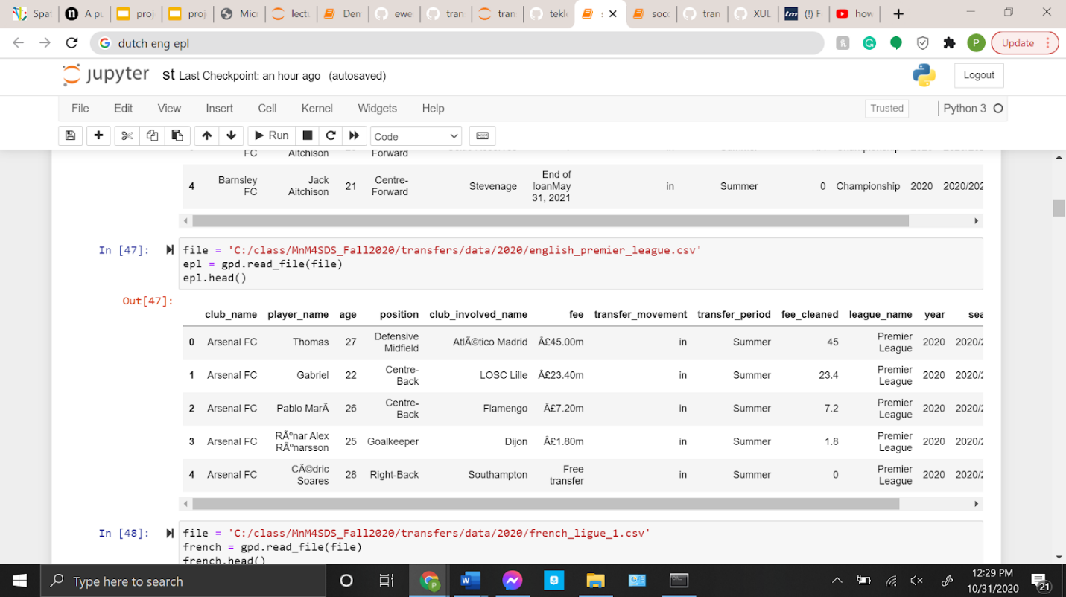

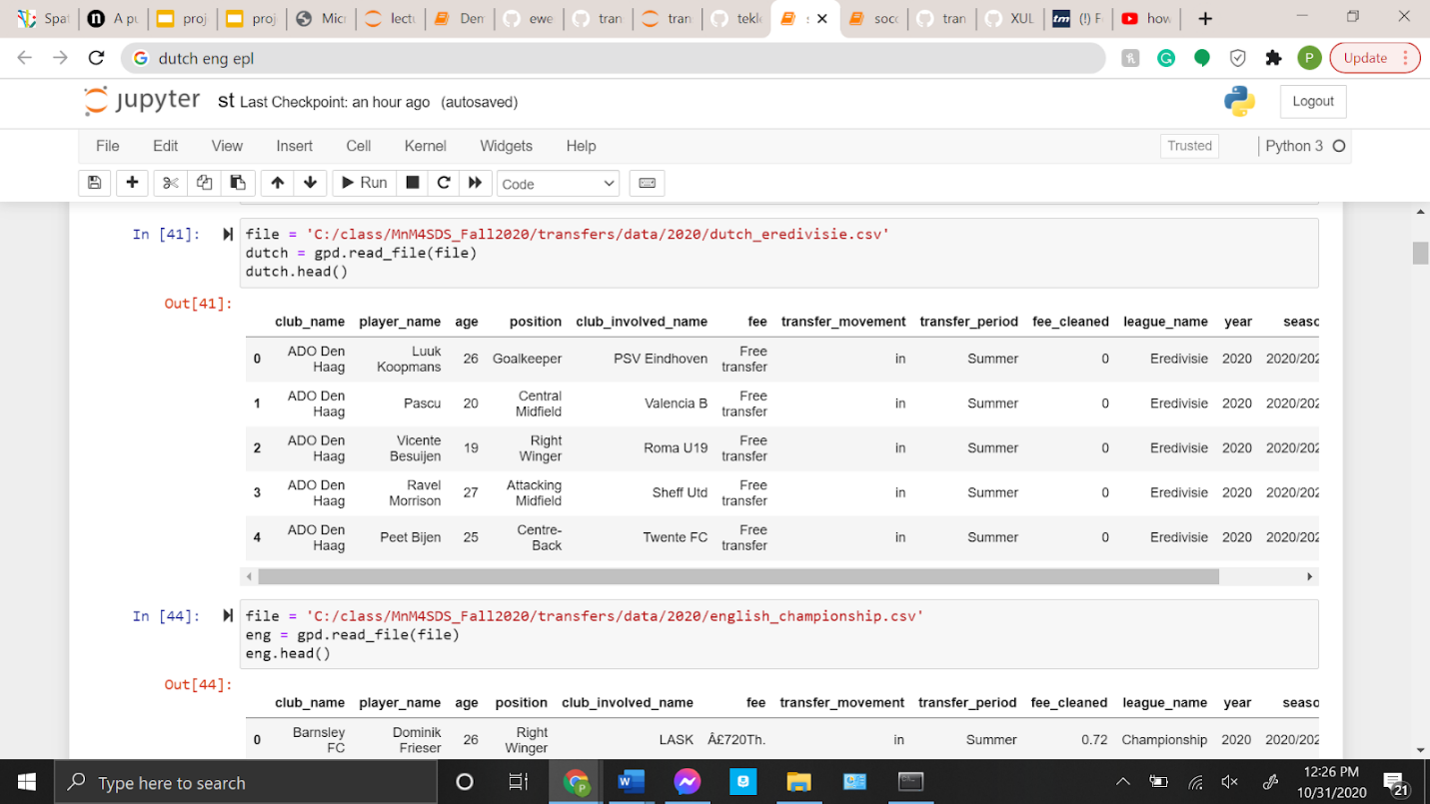

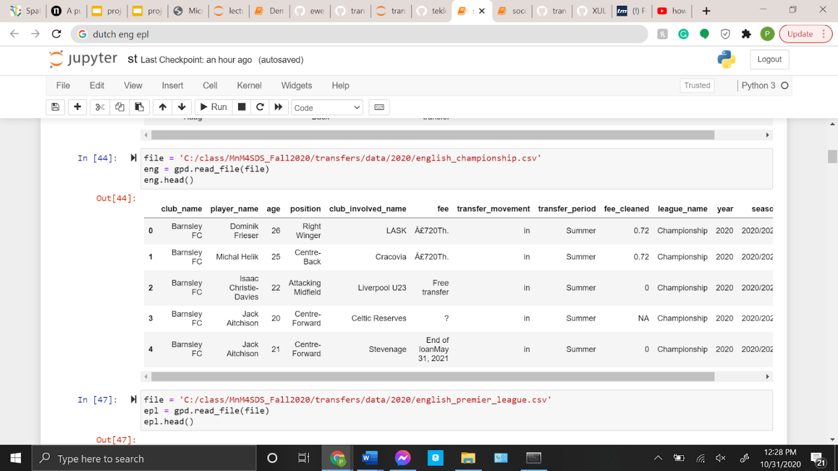

Next, I wanted to visualize the data through bar graphs where the y axis represents team names and the x-axis displays the amount they spent.

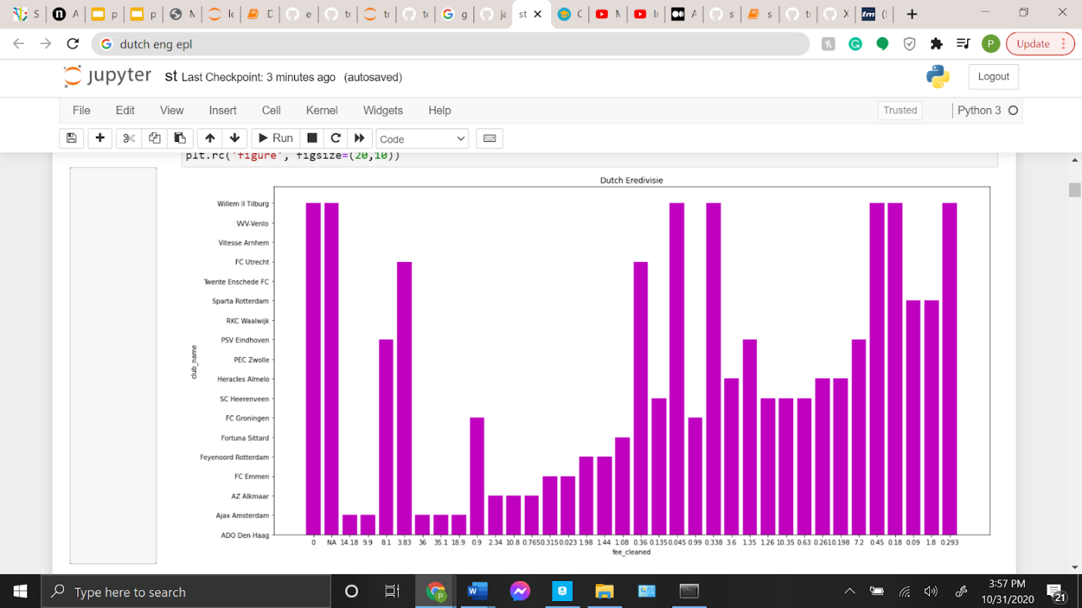

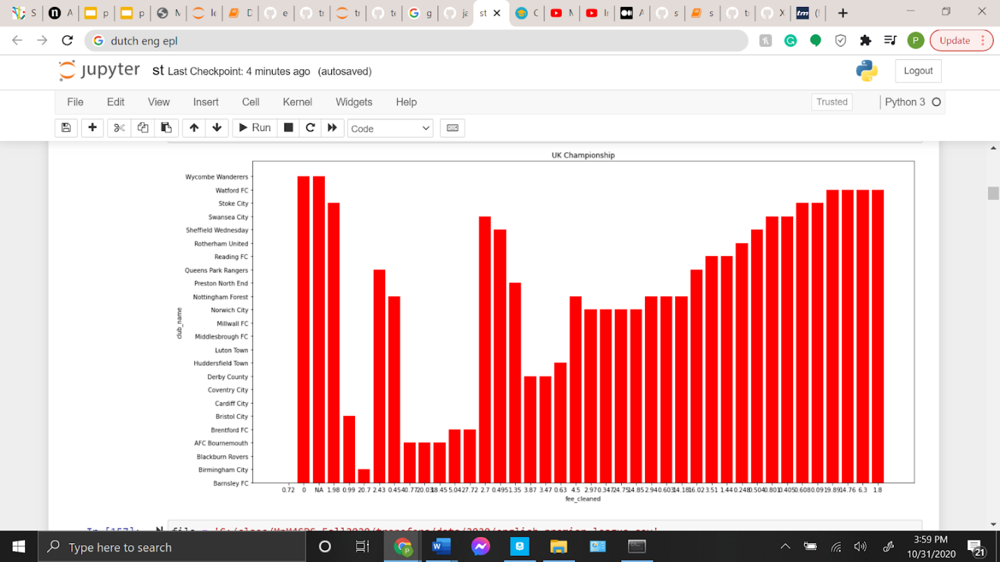

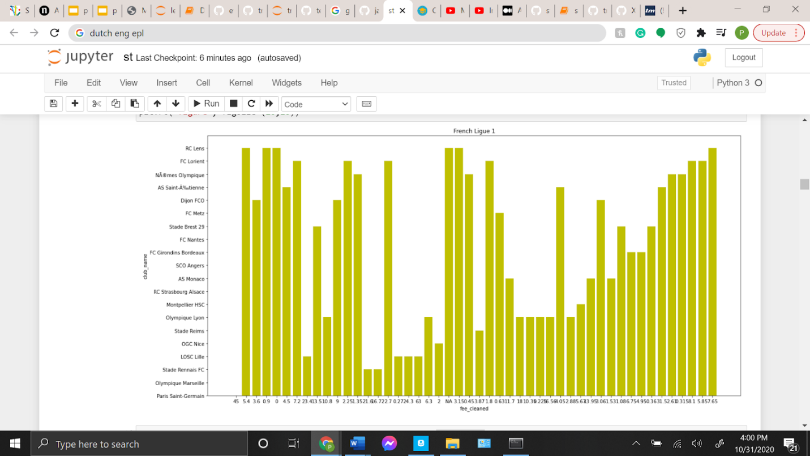

At this stage was when I realized the limitation of my project.

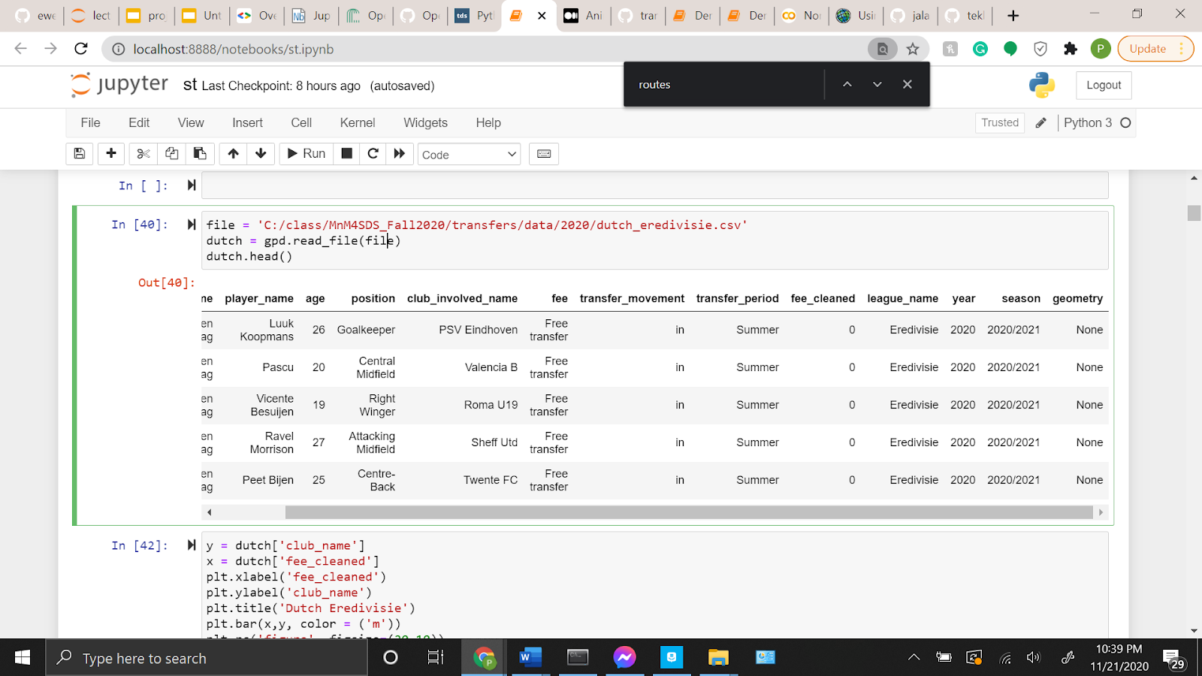

This is how I resolved the problem by creating four columns consisting of city, latitude, longitude, and geometry.

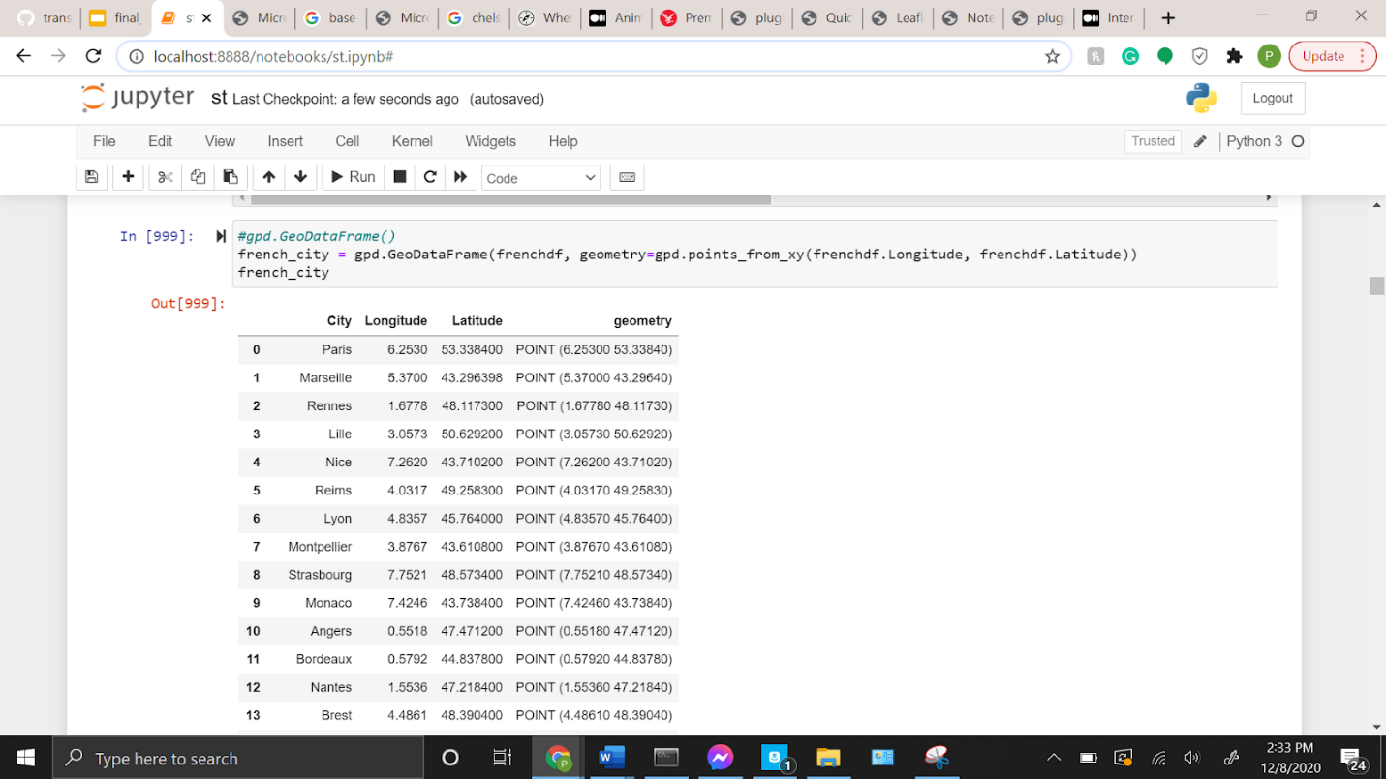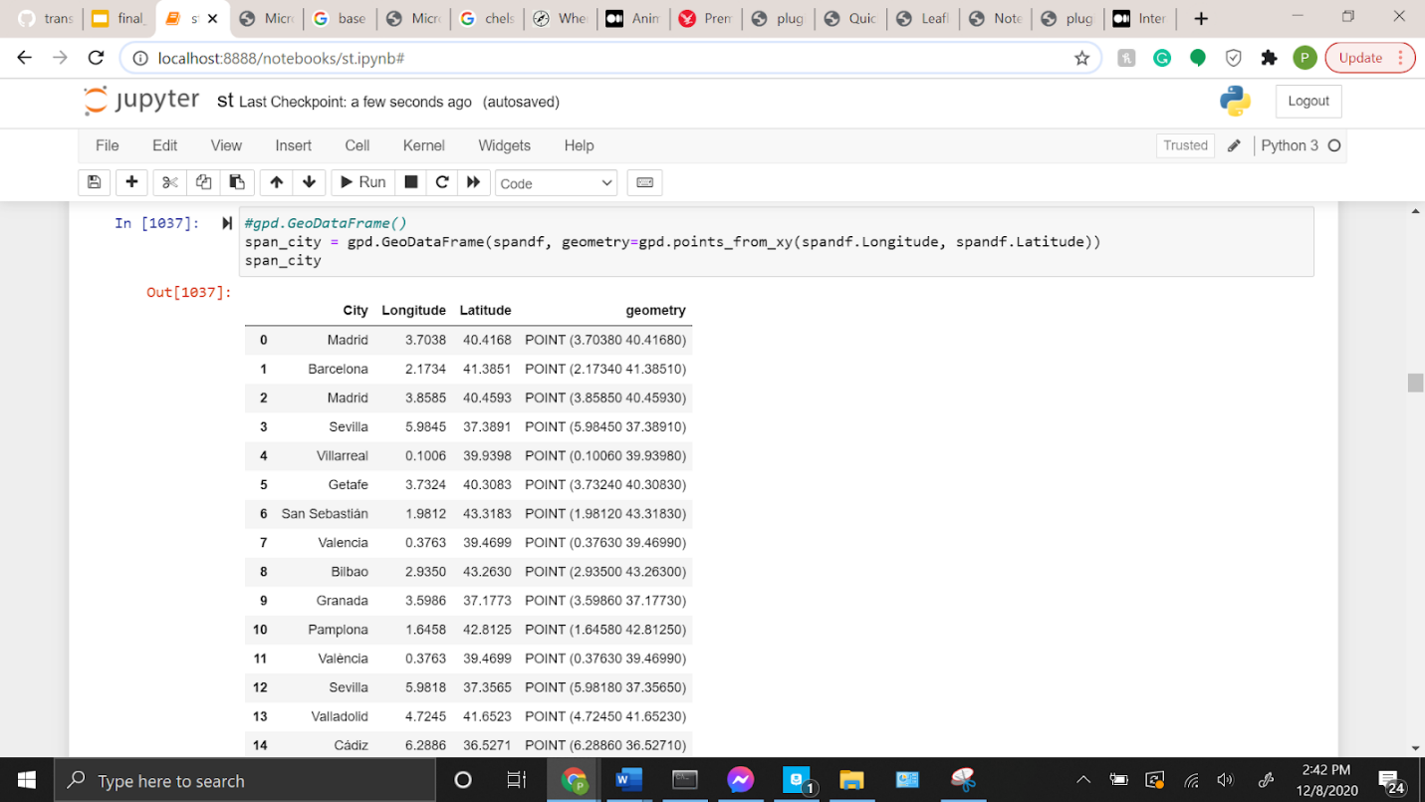

To check I researched the correct data I graphed a basic map.

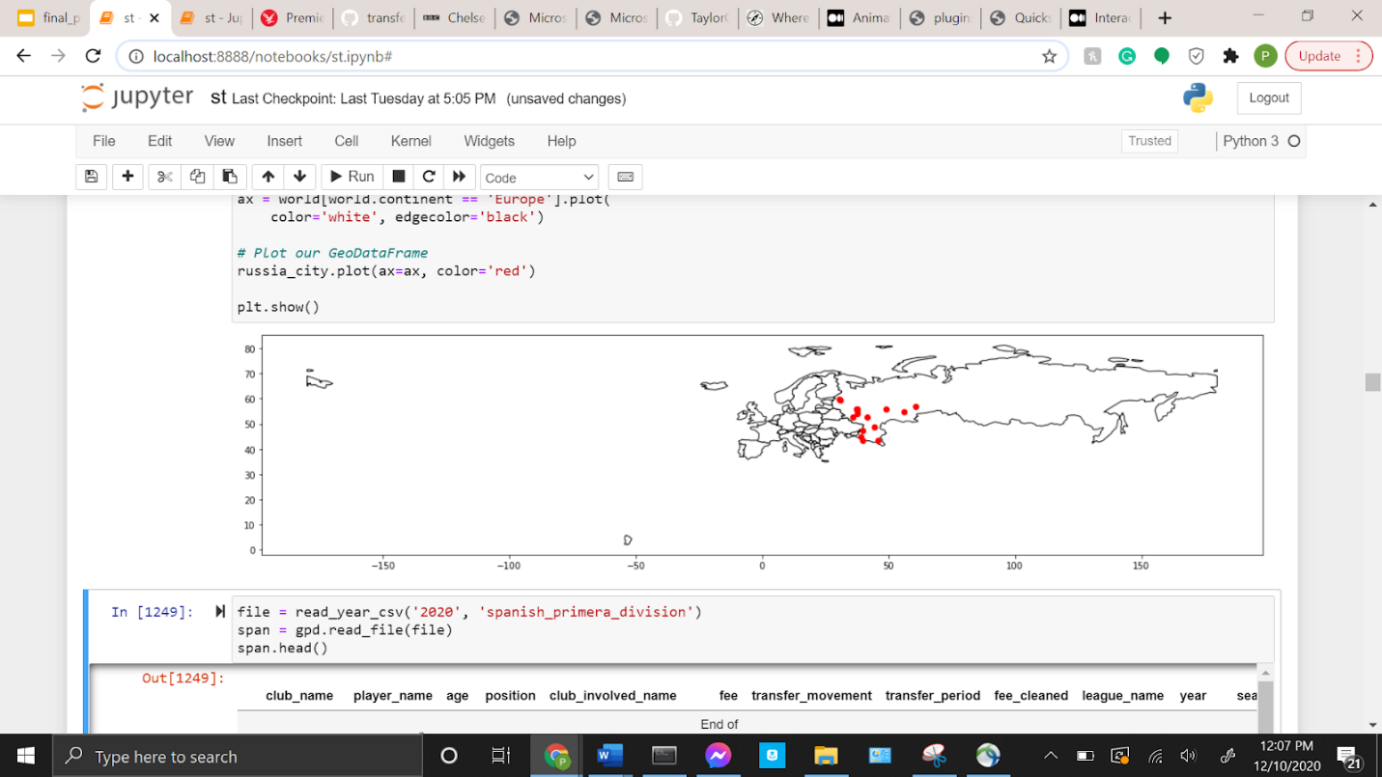

I came across these two web maps from "course materials (demo 4.3)" using bokeh and geo views and shaped the outlook of what I wanted to achieve.

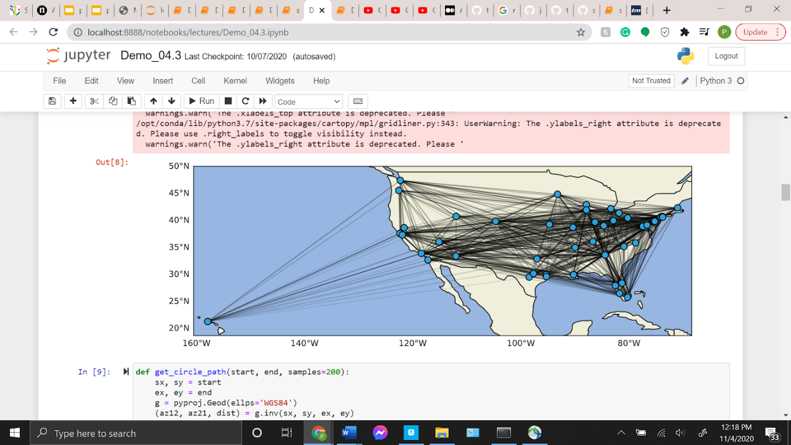

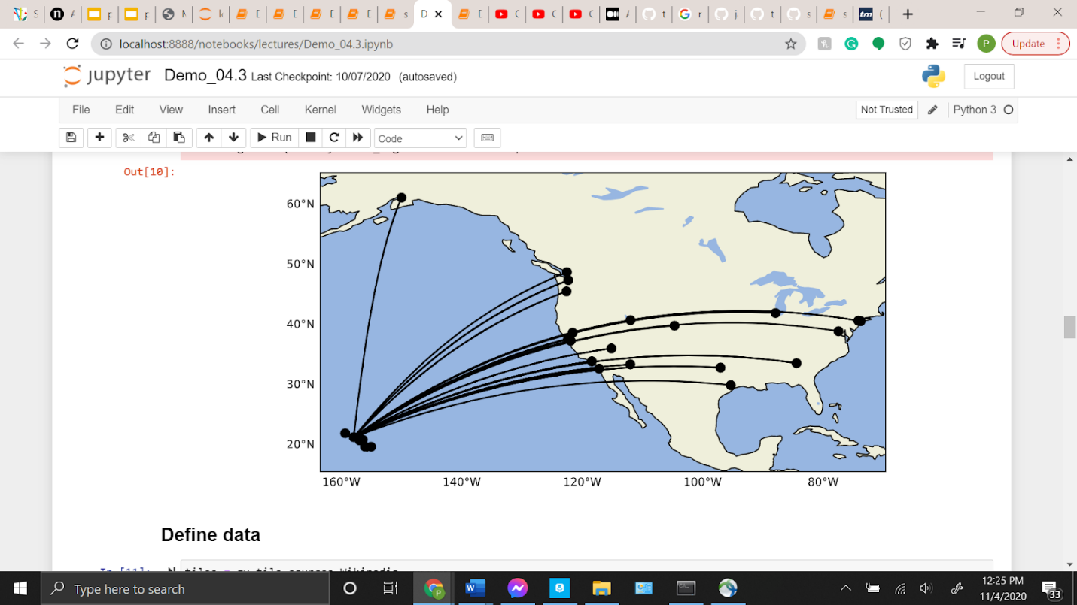

My web maps began with incorporating leaflets, yet I determined they weren’t interactive since I couldn’t select any of the points.

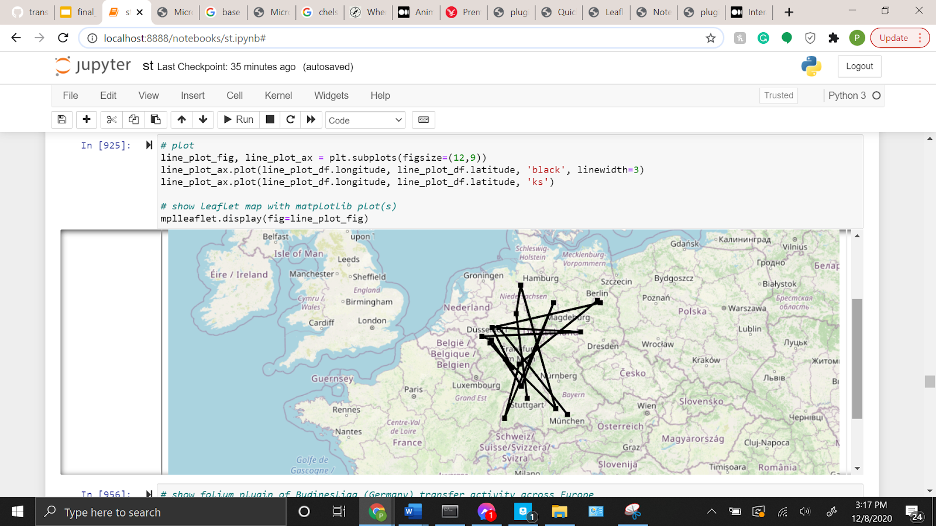 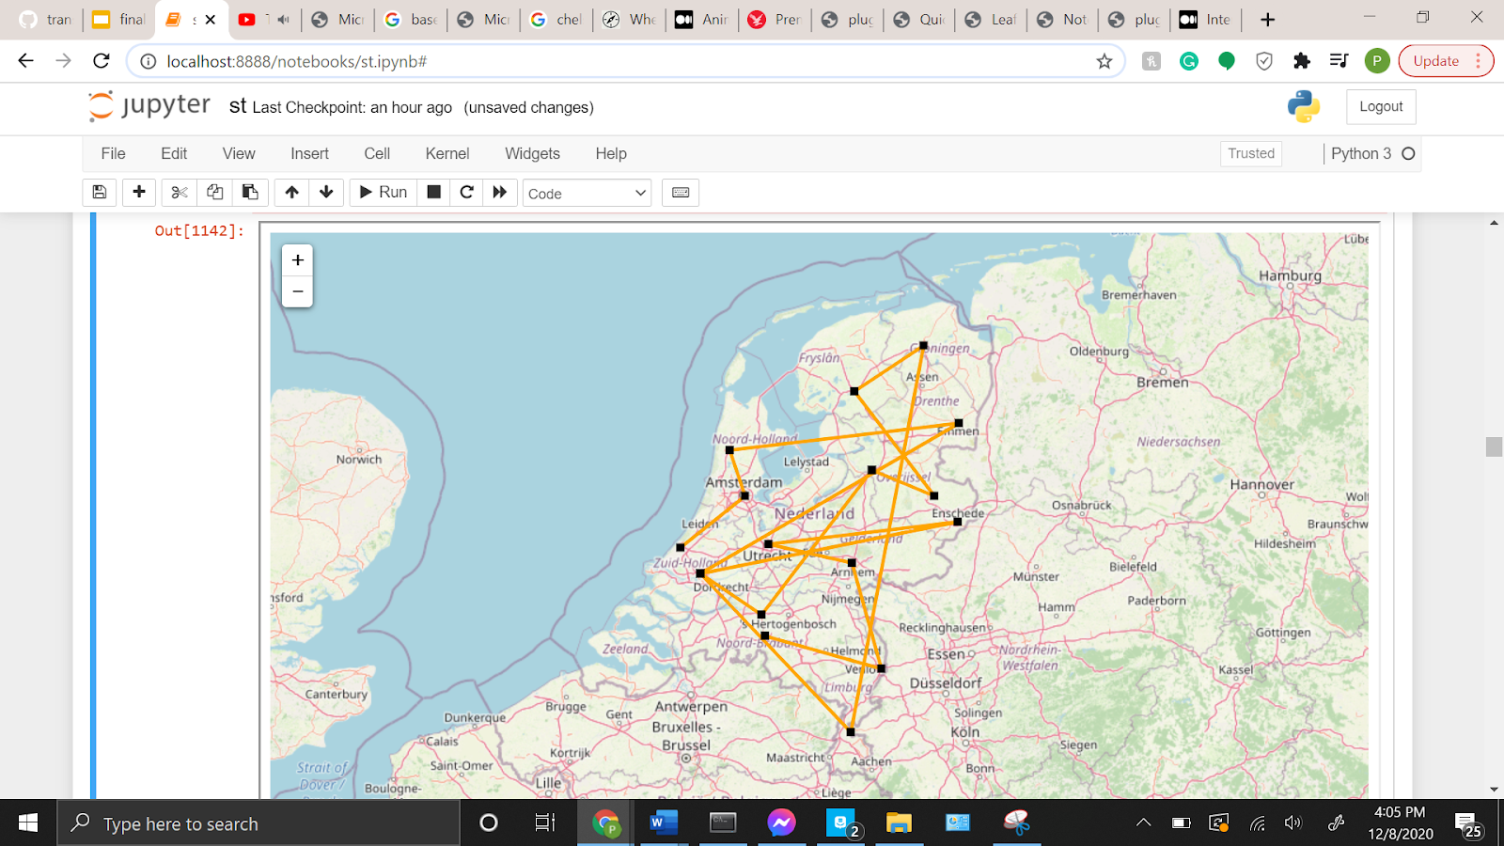

Applying folium enabled my maps to be interactive in selecting markers and reading the messages. This was the outcome to which I was pleased I was able to accomplish.

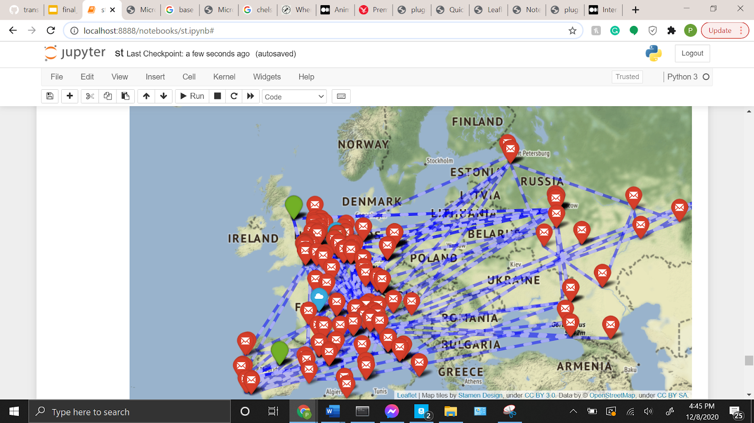

Lastly, is my animation giving an overview with past transfer windows going back from 2010 to present day which runs smoothly in my jupyter notebook.

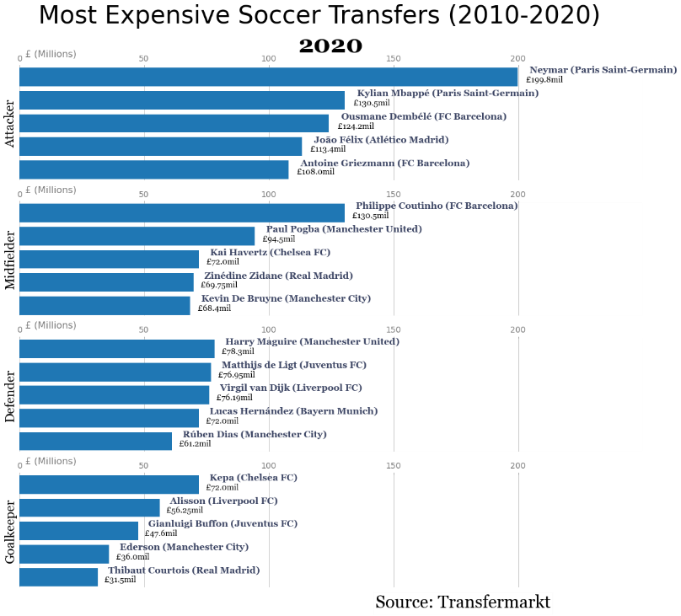

I wanted to insert an animation to envision the rise of transfer record fees for the past 10 years. The formulation of the animation began by merging individual datasets from the GitHub repository (Gouyet 2020). I followed it by inserting the four main positions in soccer, attacker, midfielder, defender, goalkeeper (Gouyet 2020). After that, inputting a new data frame to depict the top transfers for a specific year (Gouyet 2020). Finally, I used IPython’s HTML function and matplotlib’s animation function to run it successfully (Gouyet 2020).

After presenting to the class, a suggestion was made to have a zoom in zoom out scale of clicking a country then automatically zooming in and displaying the movement. To apply this suggestion to my code, I was able to find a GeoJSON file to download into my project. I set the resolution at medium and for it to only display countries in Europe. The file enabled me to create a highlighted function where if the user hovers the mouse over a country it will tell the user the country name and once the user clicks the country it will zoom into that selected area. The GeoJSON format enabled my web maps to display vectors allowing for easy parsing of the geometry and fields traveling from one country to another. In addition, I added a search function for the user to type in a country in Europe where transfer activity is taking place, and the program will run towards zooming into the searched location.

**Discussion and conclusion that also suggests limitations and future work**

The results link back to my original problem statement due to the result of my final map and animation I was able to achieve the goal I sought out in the beginning. The one limitation to the project that I had was the early stages “None” was displayed in the geometry column. However, I was able to fix this limitation through the advice from classmates by researching the latitude and longitude coordinates for where each team resides. Once I obtained the information, it widened the spectrum of creating a variety web maps.

In the future, I can apply for my work in the upcoming transfer windows in the winter and summer of 2021. The next two windows will open from January 1–January 31, 2021, and May-August 31, 2021. I expect a slight increase in an activity specifically for big clubs since they will still manage to make a profit through their adverts. Once the transaction periods are closed and I gather the data, I can use my template to create a map and animation that displays the results for 2021. I’m sure there will be twice as much activity in 2022 because by then there will be a vaccine and the smaller clubs will be able to compete for the signatures of young promising players.

Work Cited

Alan M. MacEachren & Menno-Jan Kraak (2001) Research Challenges in Geovisualization, Cartography and Geographic Information Science, 28:1, 3-12, DOI: 10.1559/152304001782173970

Arribas-Bel, Daniel (2014) Accidental, open and everywhere: Emerging data sources for the understanding of cities, DOI link: <https://doi.org/10.1016/J.APGEOG.2013.09.012>

Delaney, M. (2020, October 06). How did the Premier League spend £1.2bn in a pandemic? Retrieved December 5, 2020, from <https://www.independent.co.uk/sport/football/premier-league/premier-league-transfers-summer-window-net-spend-coronavirus-pandemic-b835179.html>

Gouyet, S. (2020, February 16). Animating Soccer Transfer Fees with Python and Matplotlib. Retrieved November 22, 2020, from <https://medium.com/analytics-vidhya/animating-soccer-transfer-fees-with-python-and-matplotlib-ea1491999ef6>

Lohr, S. (2012, February 11). The Age of Big Data. Retrieved December 12, 2020, from <https://www.nytimes.com/2012/02/12/sunday-review/big-datas-impact-in-the-world.html?_r=1>

Matchett, K. (2013, July 03). Who Has the Power in World Football Transfers: Clubs, Players or Agents? Retrieved December 6, 2020, from <https://bleacherreport.com/articles/1692650-who-has-the-power-in-world-football-transfers-clubs-players-or-agents>

Sharma, A. (2020, June 10). Geospatial Analysis using Folium in Python: Work with Location Data. Retrieved December 11, 2020, from https://www.analyticsvidhya.com/blog/2020/06/guide-geospatial-analysis-folium-python/

QuantStack. (2019, September 24). Interactive GIS in Jupyter with ipyleaflet. Retrieved December 1, 2020, from https://blog.jupyter.org/interactive-gis-in-jupyter-with-ipyleaflet-52f9657fa7a

Yoran E. Leichsenring , Rafael Stubs Parpinelli & Fabiano Baldo (2020): A method to identify defensive assignments in team-based invasion sports using spatiotemporal trajectories, International Journal of Geographical Information Science, DOI: 10.1080/13658816.2020.1813735

1. https://github.com/ewenme/transfers
2. https://www.transfermarkt.co.uk/